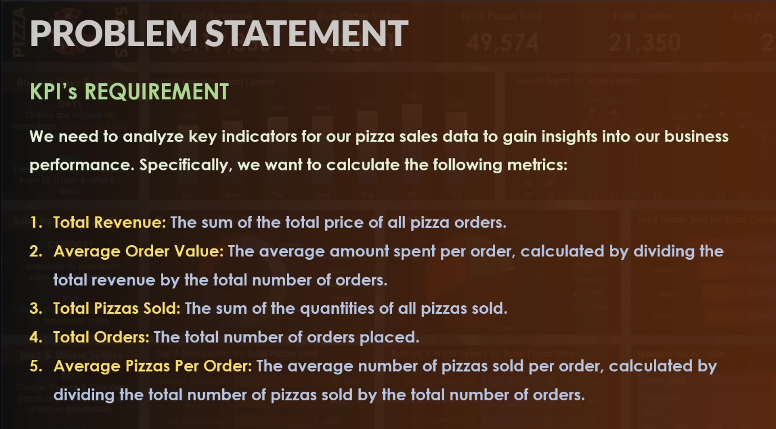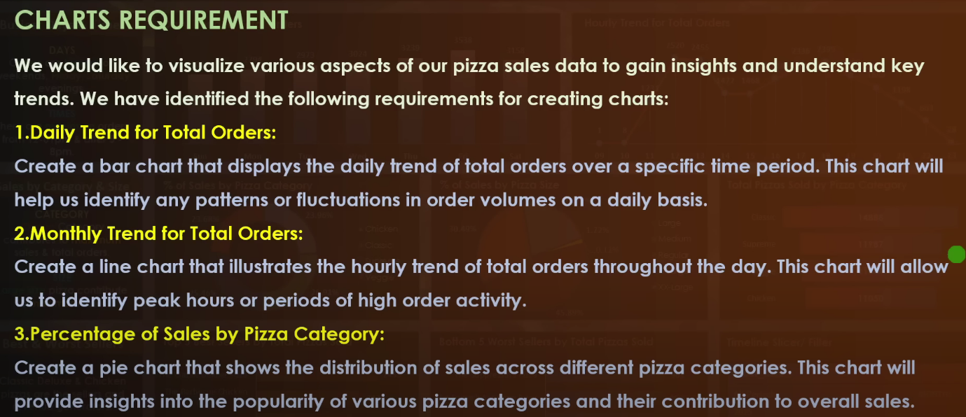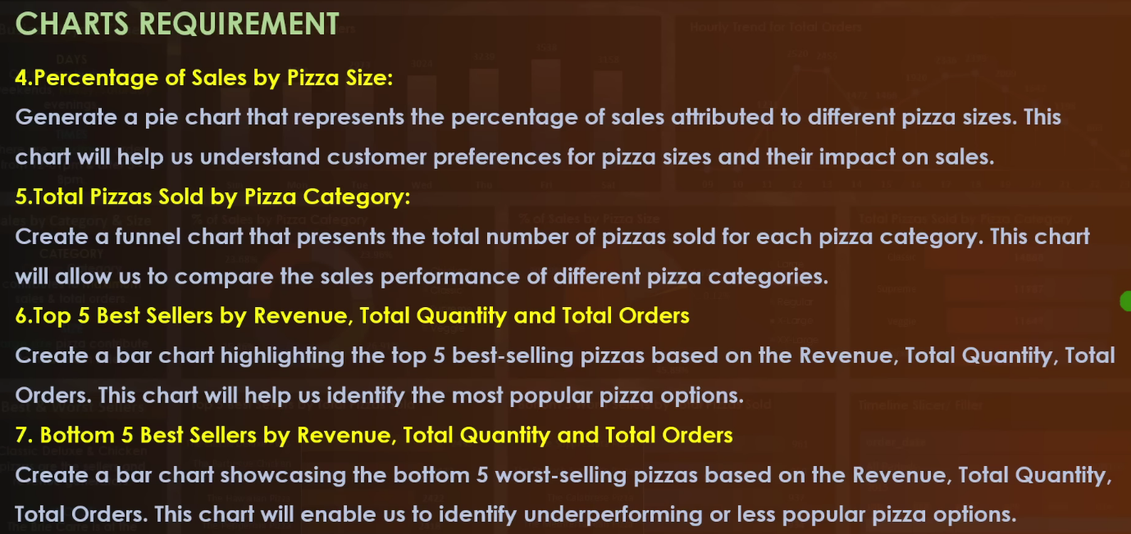

**A. KPI’S**

1. **Total Revenue :**





1. **Average Order Value**





1. **Total Pizza Sold**





1. **Total Order**



1. **Average Pizza Per Order**



**B. Chart Requirment**

1. **Daily trends for total orders**



1. **Mountly trend for total orders**

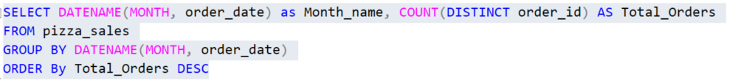

1. **Persentage of sales by pizza category**

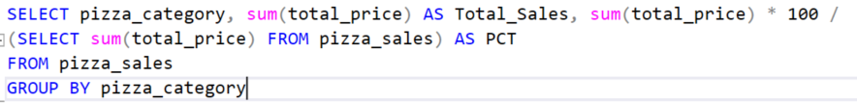

1. **Persentage of sale by pizza size**

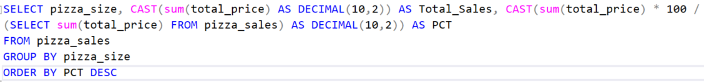

1. **Total pizza sold by pizza category**

1. **Top 5 best seller by revenue, Quantity, and total orders**

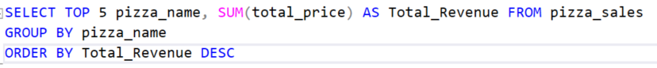

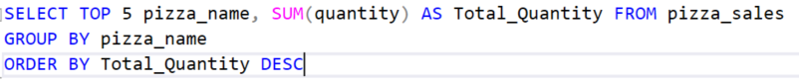

1. **Bottom 5 best seller by revenue, Quantity, and total orders**



